Project Scope Document

Improvements for WhatsApp features for the next updates

Ana Cecilia Morales Barajas

# Index

# Introduction

El siguiente documento incluye

# Scope

El alcance de este proyecto es la implementación de las mejoras de la actual aplicación “WhatsApp” en la siguiente actualización.

# High level requirements

Mencionar mejoras

1. Improvement of UX
2. Managing WH groups

# Software

Java con SDK de Android y Swift para iOS,

# Boundaries

Propuestas de mockups para mejorar.. no representa cambio en la interfaz, solo son mejoras

Mejorar ux, establecer prioridades, dividir tareas (que es lo que no es)

Deliverables

Apox 4 pags

Product Backlog description

WhatsApp features improvement

# Index

Describir…

# Introduction

El siguiente documento consiste en las mejoras de algunos features de whatsapp para que sean instalados en su siguiente actualización.

Se realizo un estudio de mercado en el que se detectaron las siguientes peticiones de usuarios:

-

# Project components

Este documento incluye las historias de usuario, así como el el sizing, sprint, mockup y prototipo.

# User Stories

## User Stories Sizing

As a user of WhatsApp, I want to have a quick access to some contacts, so that I don’t have to search for them every time I want to write them or scroll down to find them. (favoritos)

As a user of WhatsApp, I want to have the option to split my individual chats from group chats so that I can focus in “important things” or in

As a user of WhatsApp, I want to see my own profile picture in the main screen, and be able to change it easily so that I don’t have to go to “settings” and then “profile” to do it. (it is a long process).

As a user of WhatsApp, I want to write to some unknown number without having to save it first, so that if I don’t need that contact later or I don’t want it in my phone, it doesn´t occupy space in my memory and it is not there disturbing.

As a WhatsApp user I would like the option of having a list of people who have restricted the privileges of viewing my personal information, such as profile picture, status, etc. so that people who are not that trustworthy, but I have to be in contact with them, cannot stalk me.

Also, I want to have a quick access to move them from my contacts to that “others” list and vice versa.

2

As a user of WhatsApp, I want to write to some unknown number without having to save it first, so that if I don’t need that contact later or I don’t want it in my phone, it doesn´t occupy space in my memory and it is not there disturbing

As a WhatsApp user I would like the option of having a list of people who have restricted the privileges of viewing my personal information, such as profile picture, status, etc. so that people who are not that trustworthy, but I have to be in contact with them, cannot stalk me.

2

As a user of WhatsApp, I want to have the option to split my individual chats from group chats so that I can focus in “important things” or in

Also, I want to have a quick access to move them from my contacts to that “others” list and vice versa.

3

As a user of WhatsApp, I want to have a quick access to some contacts, so that I don’t have to search for them every time I want to write them or scroll down to find them.

1

As a user of WhatsApp, I want to see my own profile picture in the main screen, and be able to change it easily so that I don’t have to go to “settings” and then “profile” to do it. (it is a long process).

***Revisar Presentación – Gestión de los proyectos de desarrollo para hacer las historias de usuario

Cuál es la verbalización de las historias,

Organizarlas de acuerdo a dificultad y tamaño.

Cada click es un feature

Título en el cuadro

Abajo describo cada uno

**Favoritos**

1. **DB**
   1. **Crear campo de favoritos en la base de datos,**
2. **Back-end**
3. **Front-end**
   1. **Crear botón de favoritos**
   2. **Crear vista de los contactos favoritos**

**Split**

Back – agregar campo donde diga si es grupo o no

Front if mostrar grupos o no

Foto de perfil

Puro front – implementar el código de cambio de imagen en la pantalla principal, y hacer ajustes en la vista.

**Escribir a numero desconocido**

1 . agregar botón a la pantalla principal

Agregar al local storage de la aplicacoion -- front

Hacer vista de l aventana en la que se agrega el numero desconocido

Leer dato de input del campo de numero, y agregarlo al listado de contactos y te redirija a la conversación de ese numero.

Db – agregar campo a db que se llame constraints – ture amigo, false es conocido.

Front – obtener esa información y

# Sprint Planning

Sprints – es un lapso de tiempo en el que planeo terminar actividad

Sprint 1 -- ( de una a 4 semanas)

Sprint 2 – ( de dos a 1 semana)

Sprint 3 – ( 1 semana)

# Product Mockup

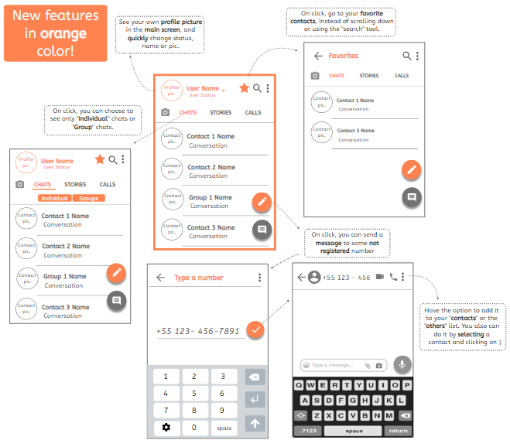

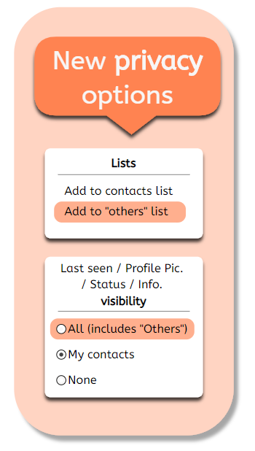

* <https://app.moqups.com/unsaved/d9e40f03/view/page/a3b42c0ba>

# Prototype

* <https://projects.invisionapp.com/d/main#/projects>

# Conclusions

Aprox 6 pags